**Diksha dhakne**

**1)creating table**

**CREATE TABLE employees (**

**emp_id INT PRIMARY KEY,**

**name VARCHAR(100) NOT NULL,**

**department VARCHAR(50),**

**salary DOUBLE,**

**join_date DATE**

**);**

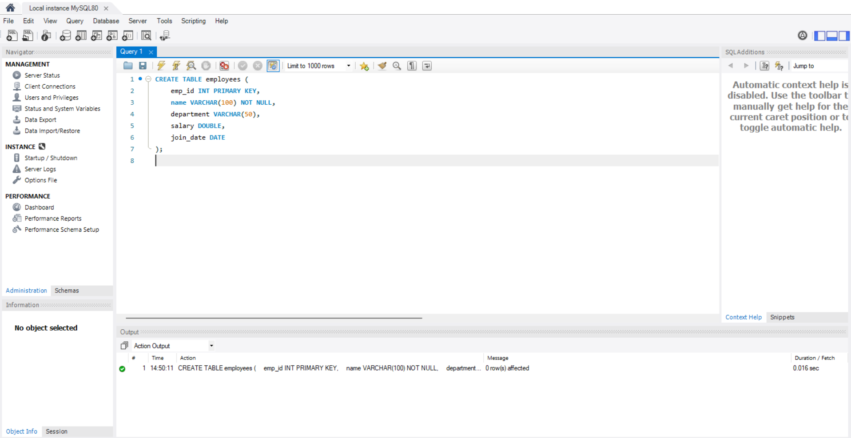

**2)insert query**

**INSERT INTO employees (emp_id, name, department, salary, join_date) VALUES**

**(201, 'Rahul Verma', 'HR', 47000, '2022-05-10'),**

**(202, 'Sneha Patil', 'IT', 78000, '2021-02-14'),**

**(203, 'Amit Joshi', 'Finance', 61000, '2020-09-21'),**

**(204, 'Neha Sharma', 'IT', 83000, '2023-01-11'),**

**(205, 'Karan Mehta', 'Marketing', 54000, '2022-07-30');**

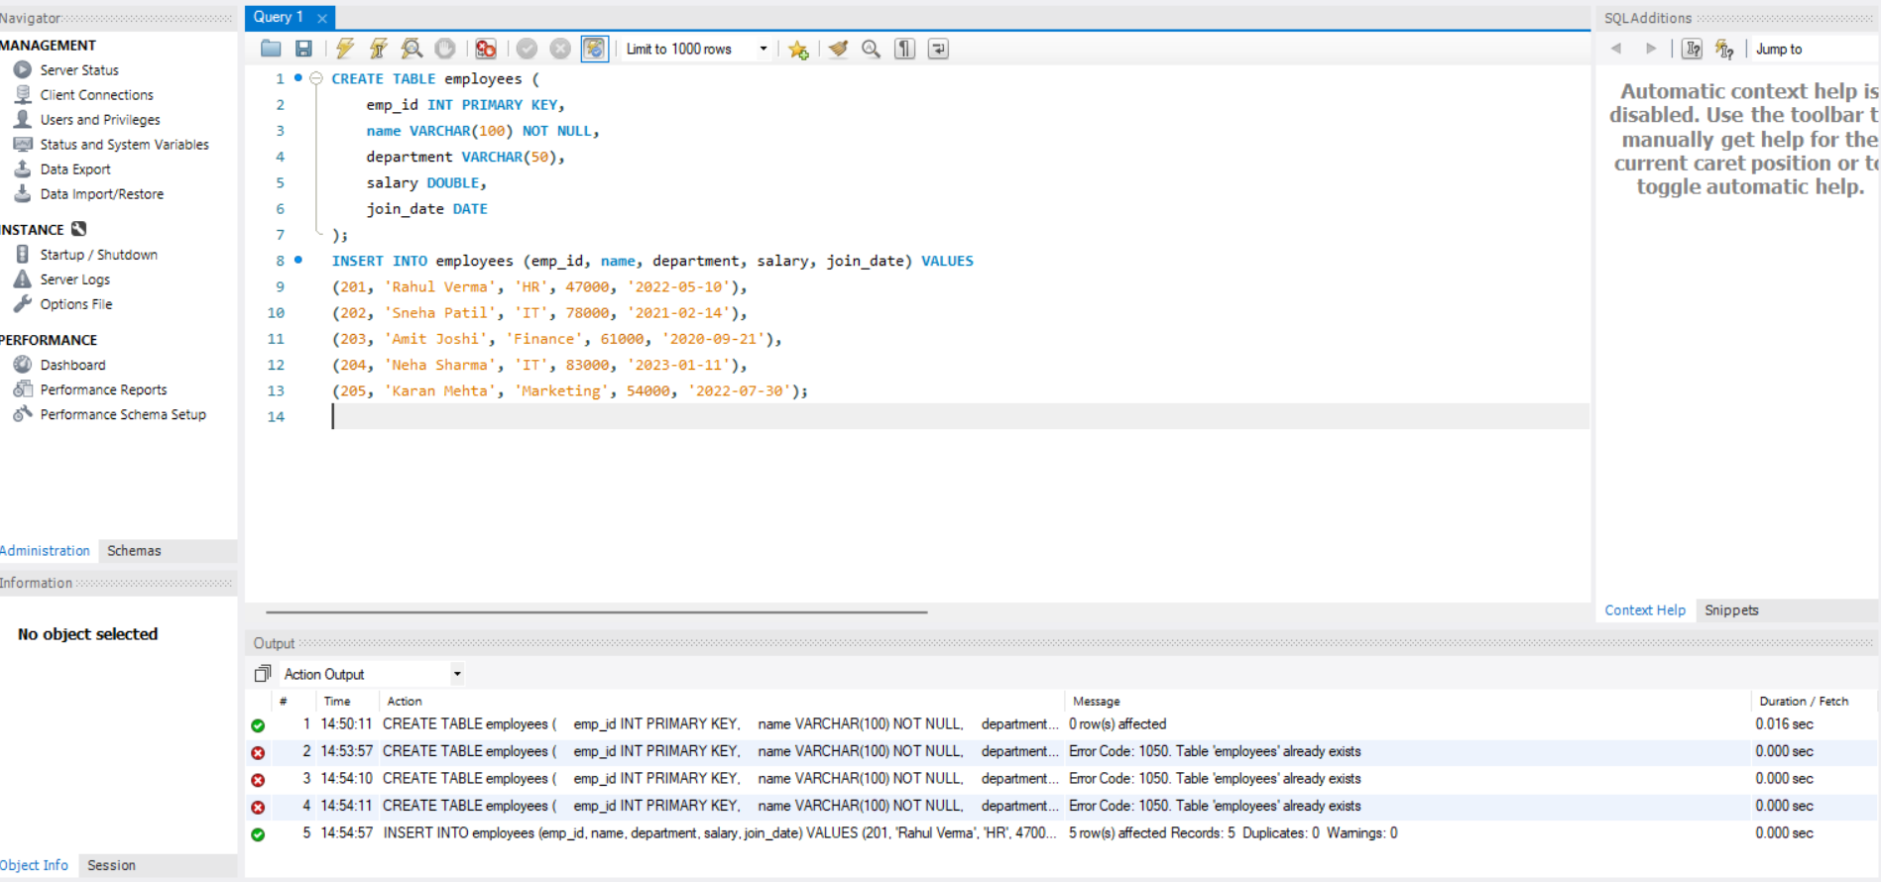

**3) select query**

**SELECT * FROM employees;**

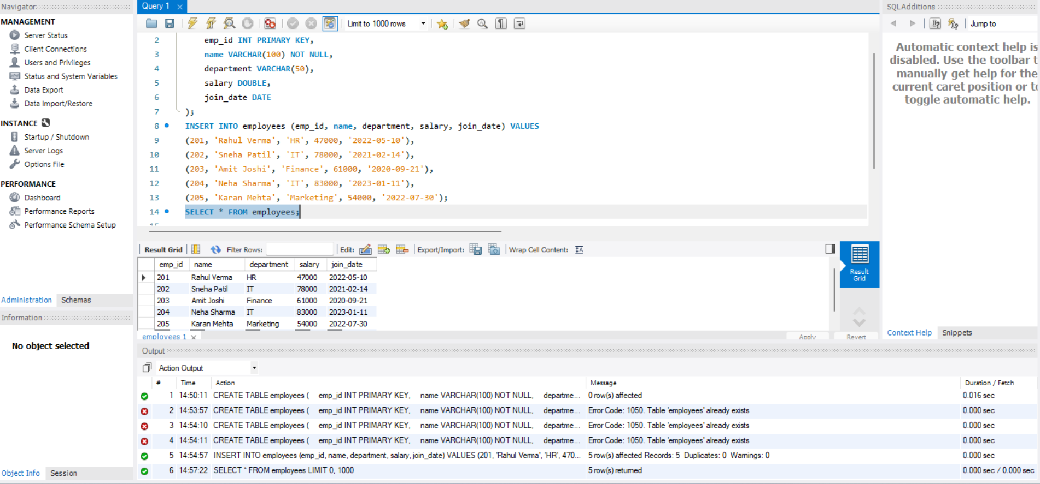

**SELECT name, department FROM employees;**

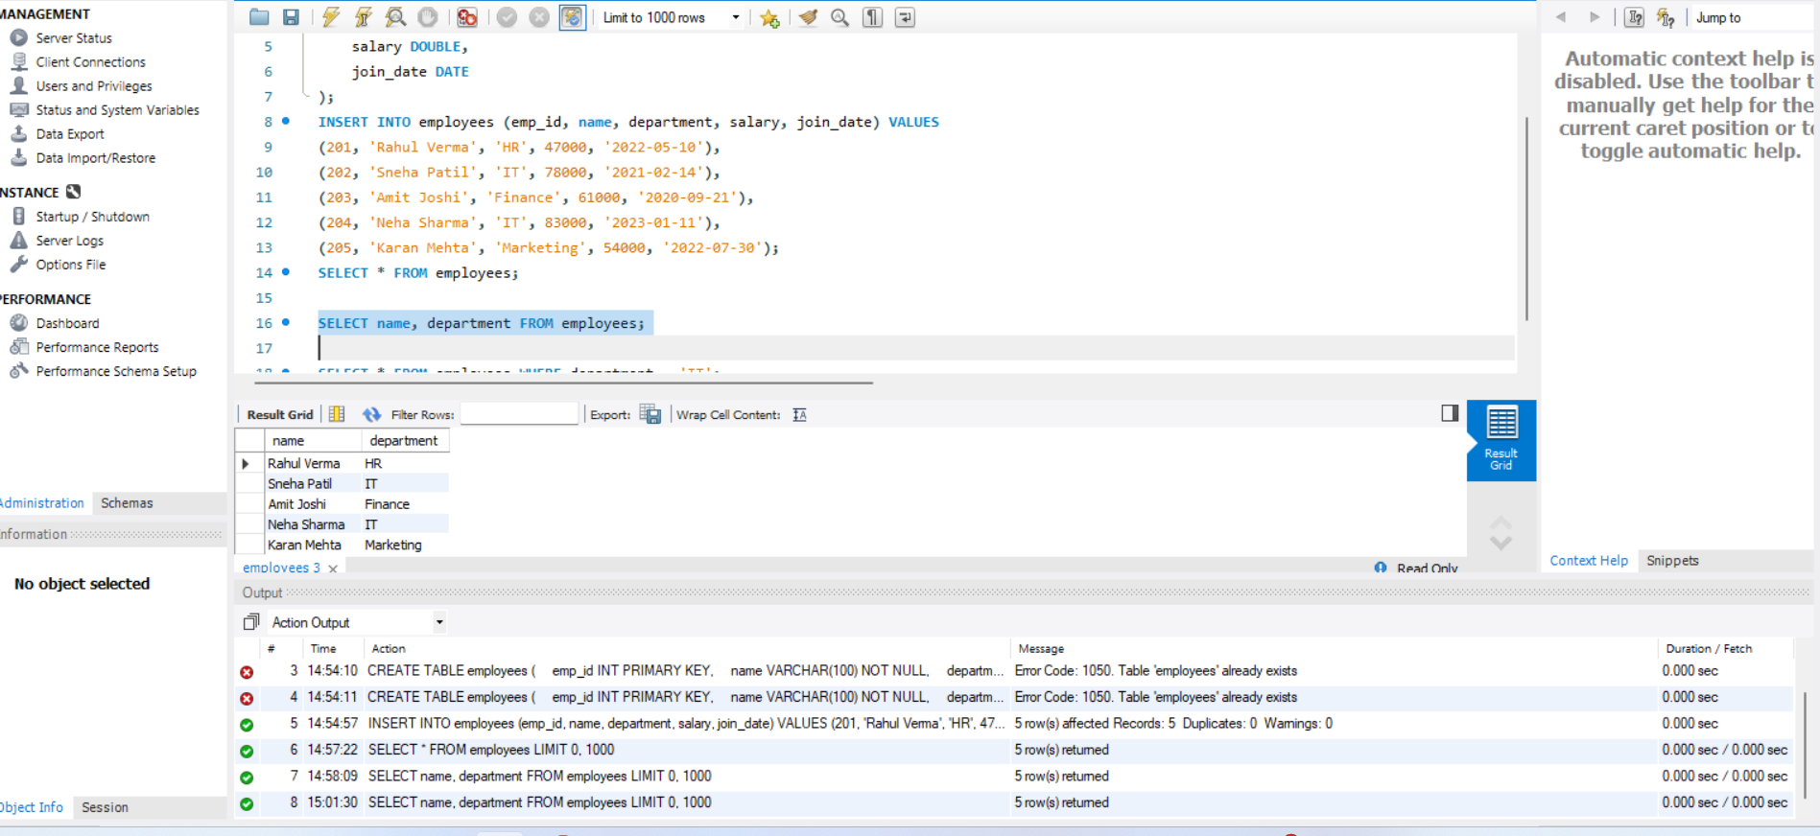

**SELECT * FROM employees WHERE department = 'IT';**

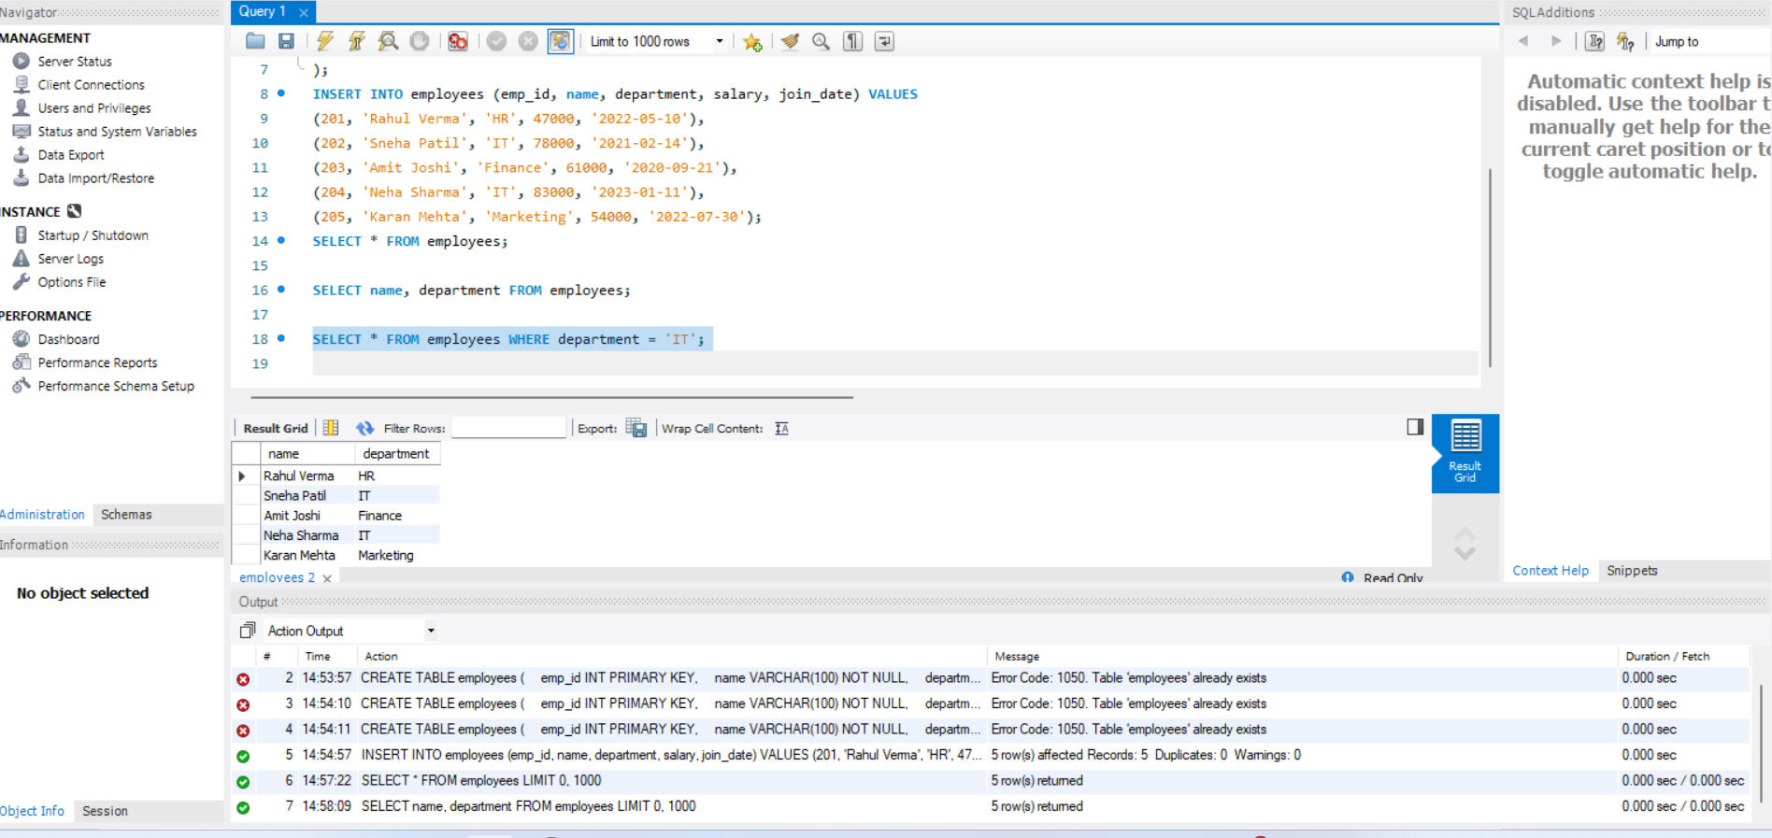

**4) AND ,IN BETWEEN AND LIKE**

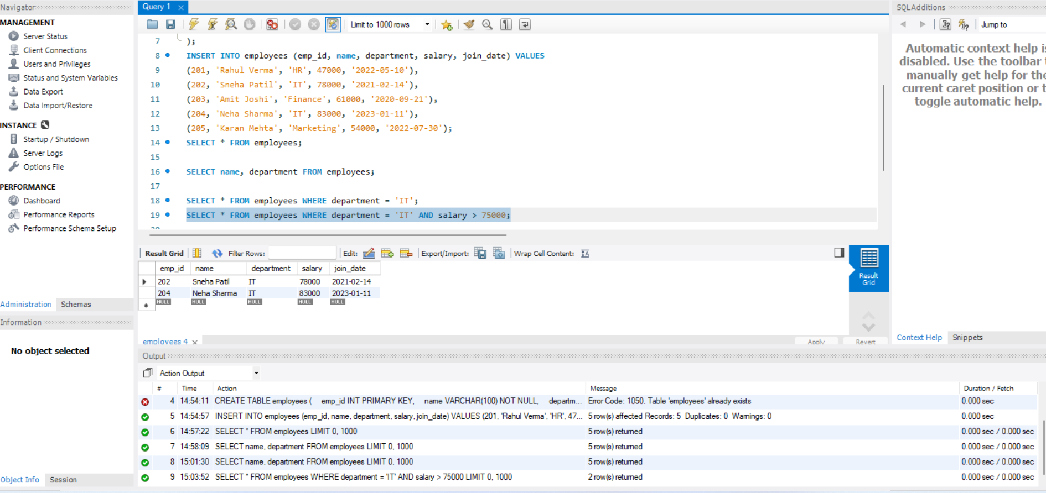

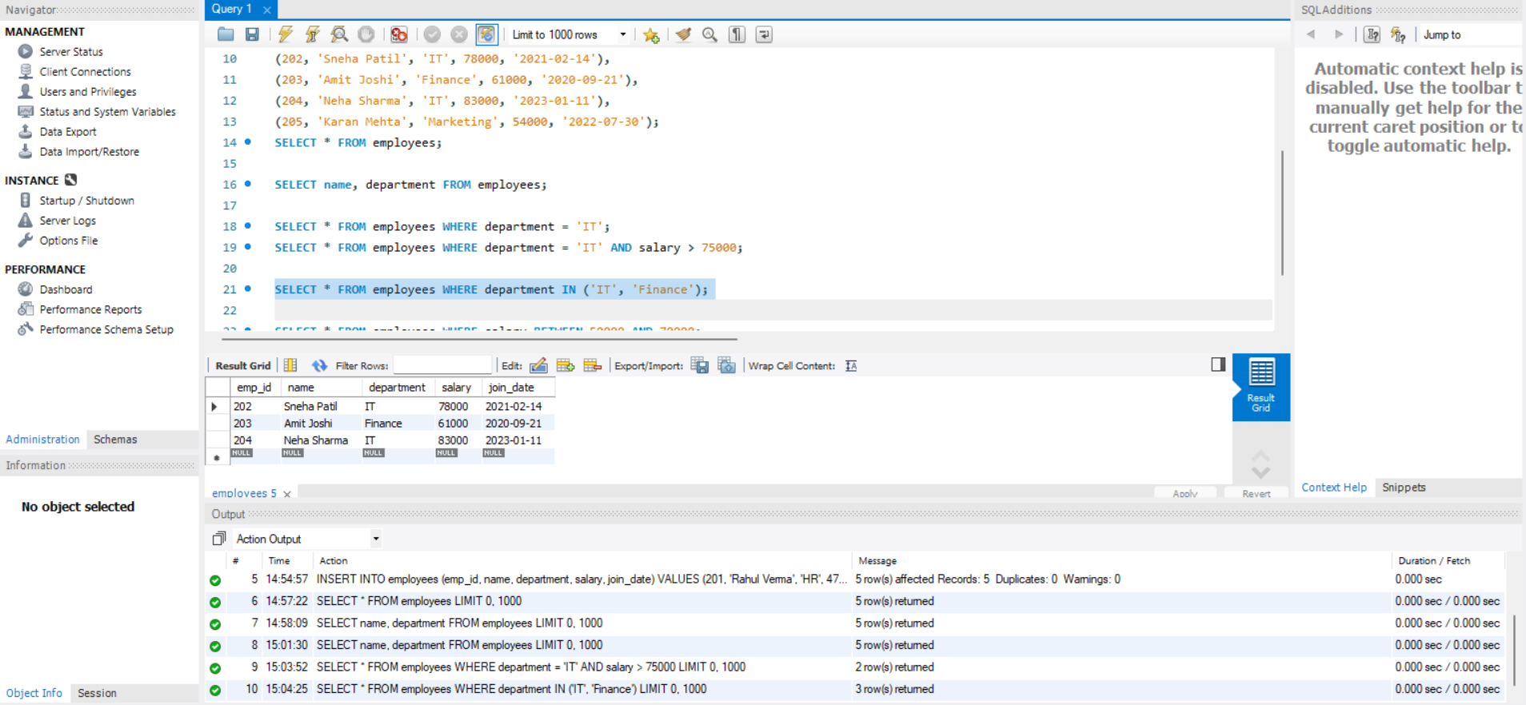

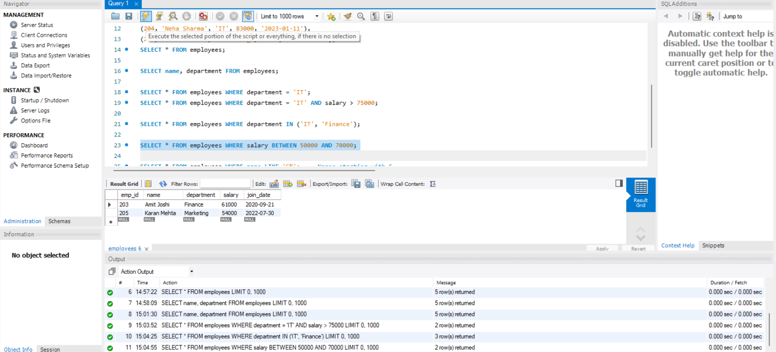

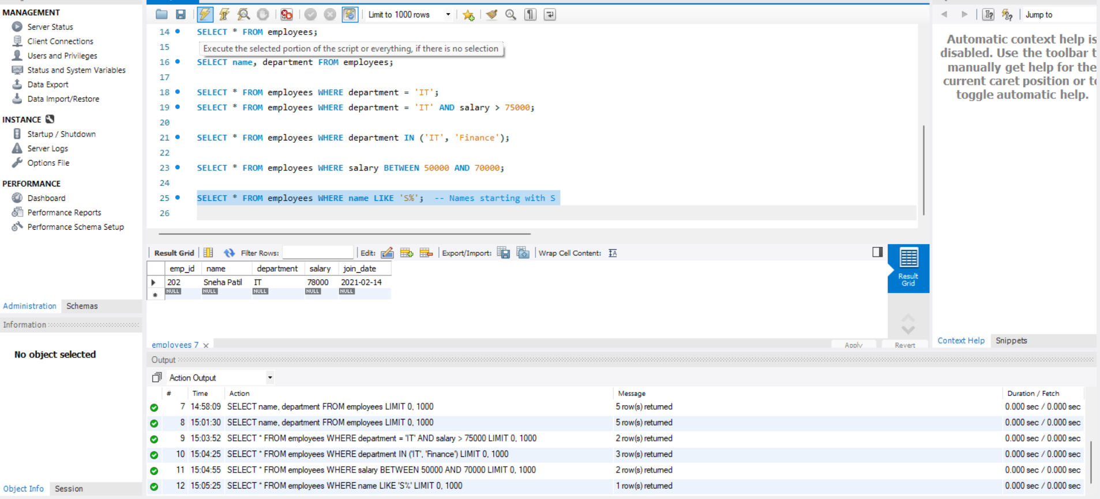

**5)CLAUSE-ORDERBY,WHERE,HAVING**

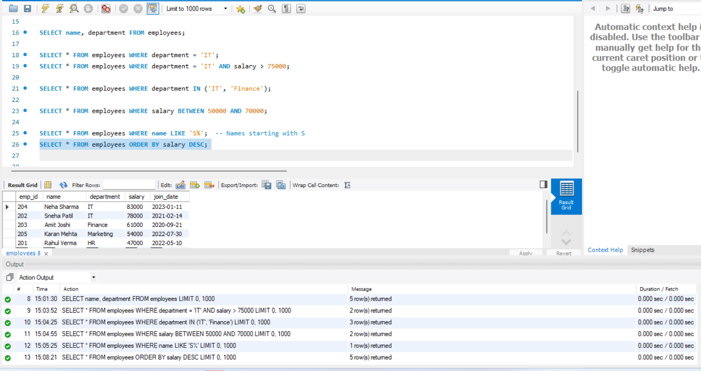

**6) UPDATE QUERIES**

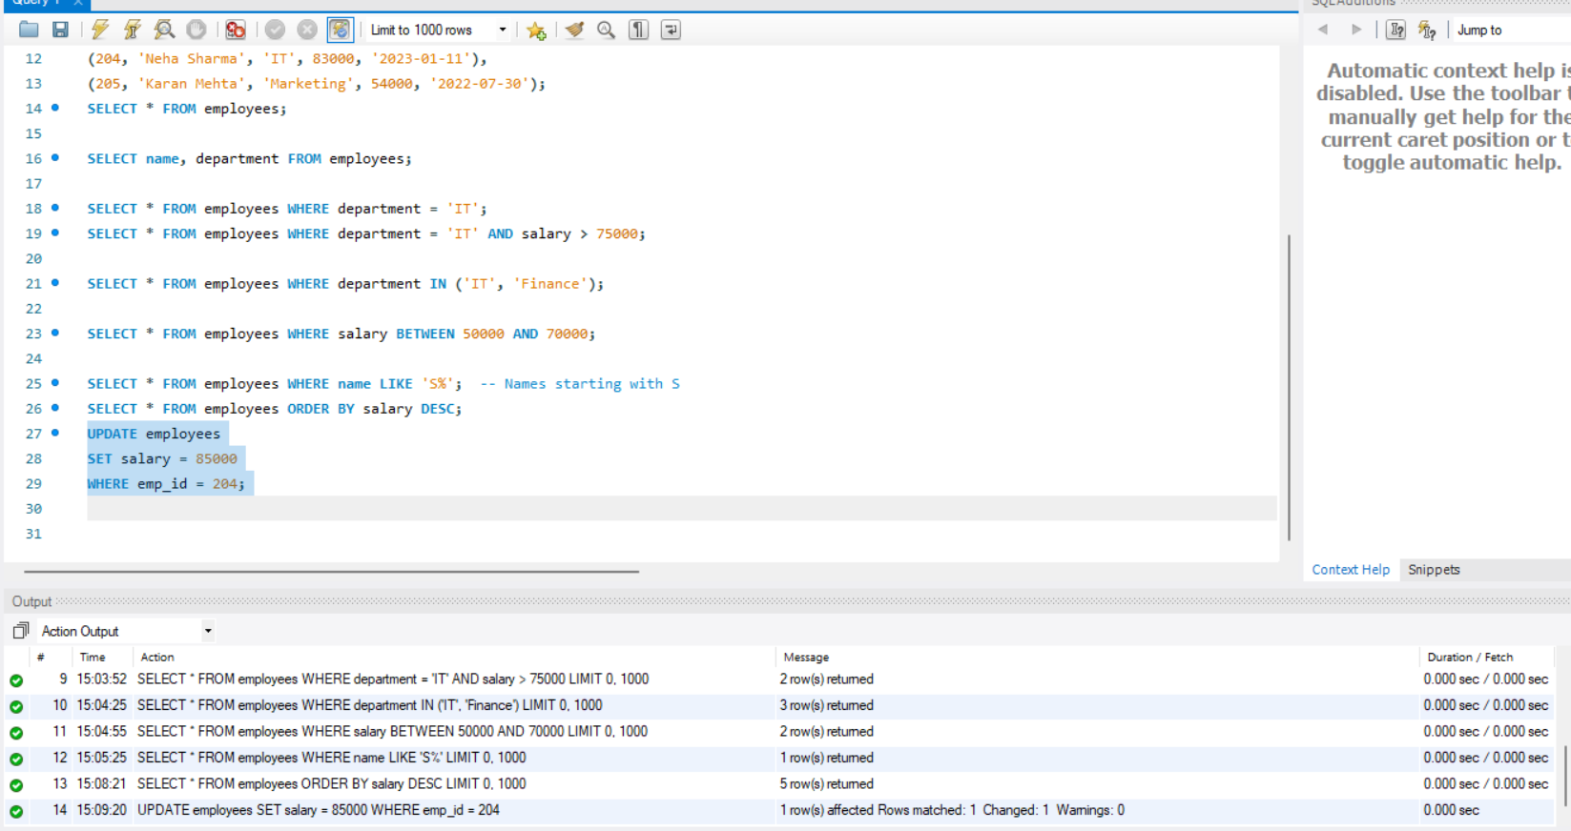

**7) DELETE QUERY**

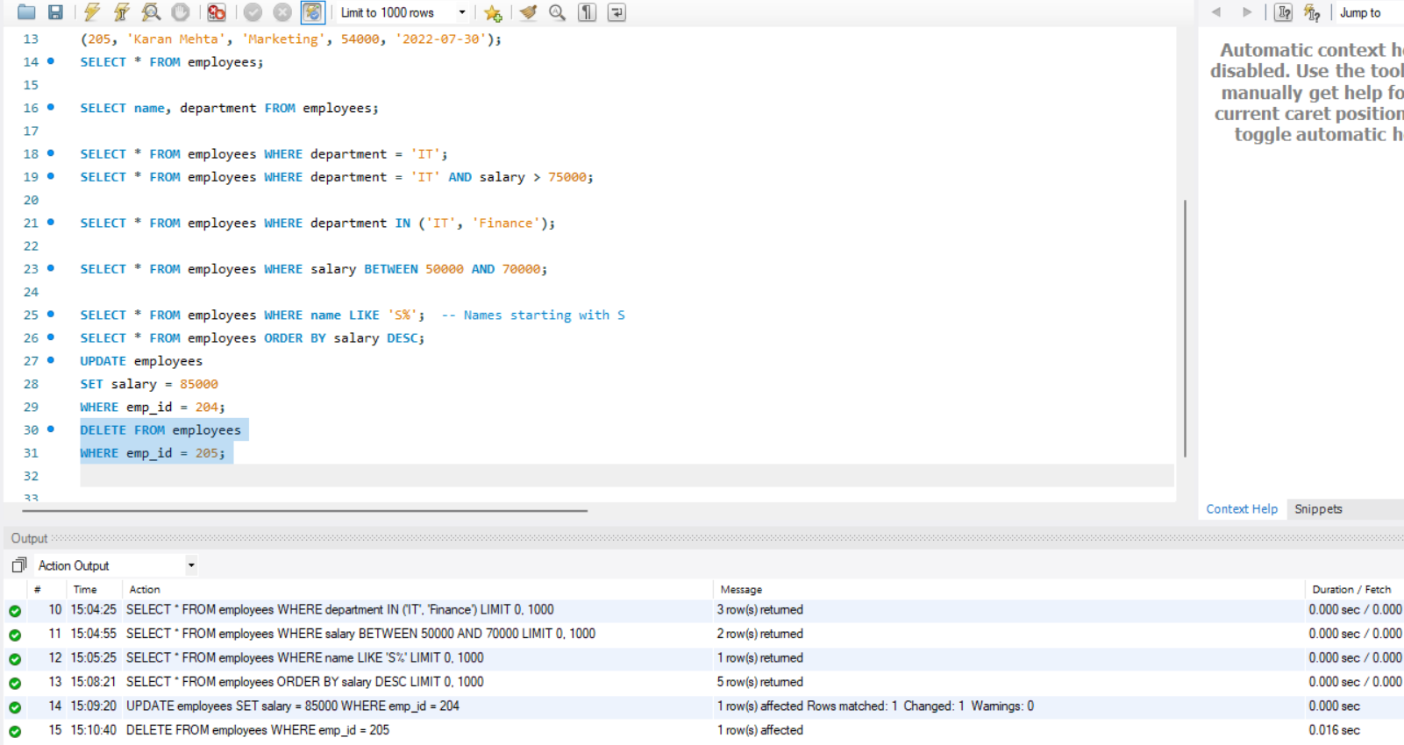

8) GROUP BY with AVG & COUNT

